**CSE523** Machine Learning

Project: Shipment Price Prediction

Weekly Project Report: March 10, 2023

Team: **Revolution**

| Team Members | Enrolment-ID |
| --- | --- |
| Deep Patel | AU2040250 |
| Roshni Navdiya | AU2040114 |
| Aditya Padhariya | AU2040151 |
| Keval Parmar | AU1940133 |



* **Task Performed this week:**

1. This week, we focused on advanced data cleaning. Specifically, we used the dropna() function to remove any rows with missing values from our dataset.
2. We extended our analysis to include 9 parameters and conducted a correlation analysis to gain insights. I presented my findings and discussed their implications, limitations, and potential impact.
3. We have analyzed Freight_cost_by_order parameter with other parameter like shipment_mode, Order_by_contry, Top_ten_contry, Manufacturing site,etc.

* **Outcomes of the tasks performed:**

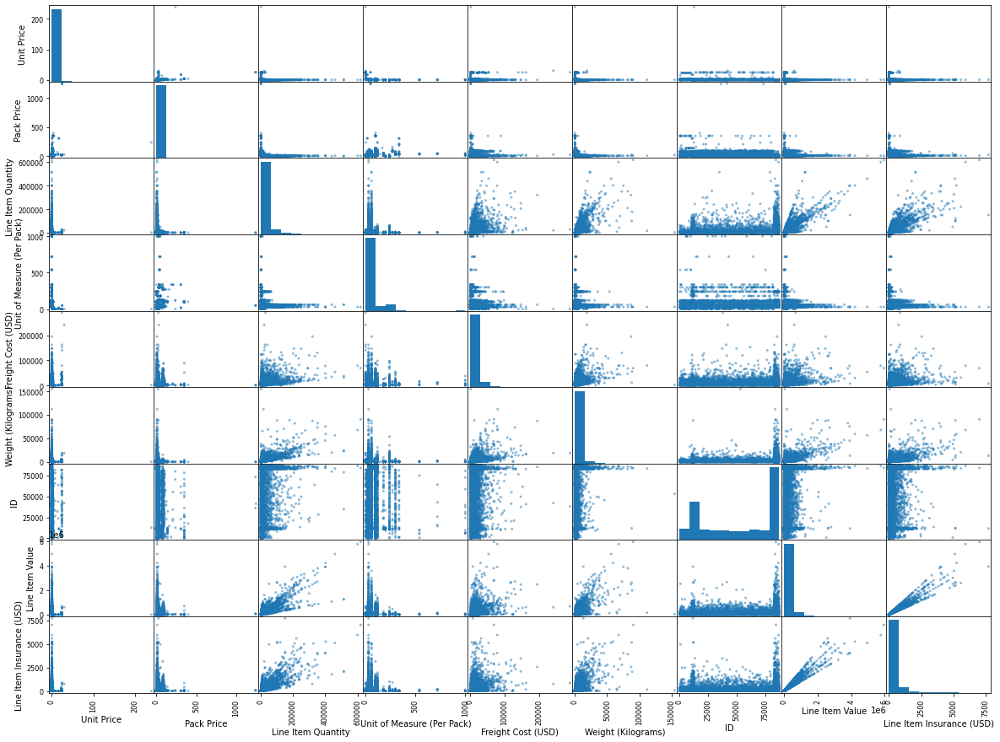

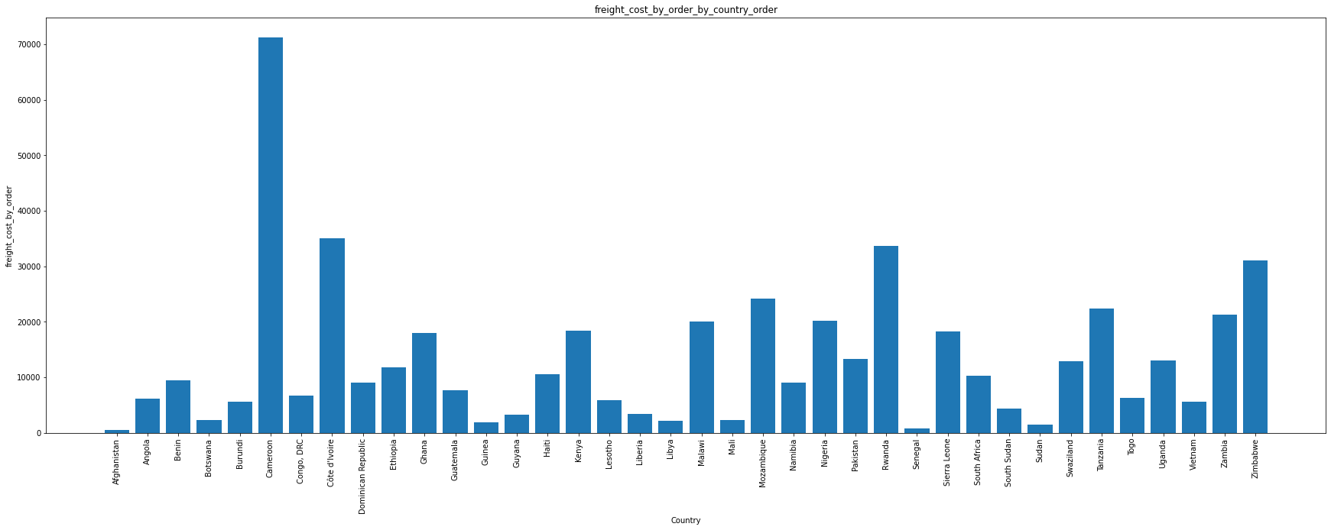

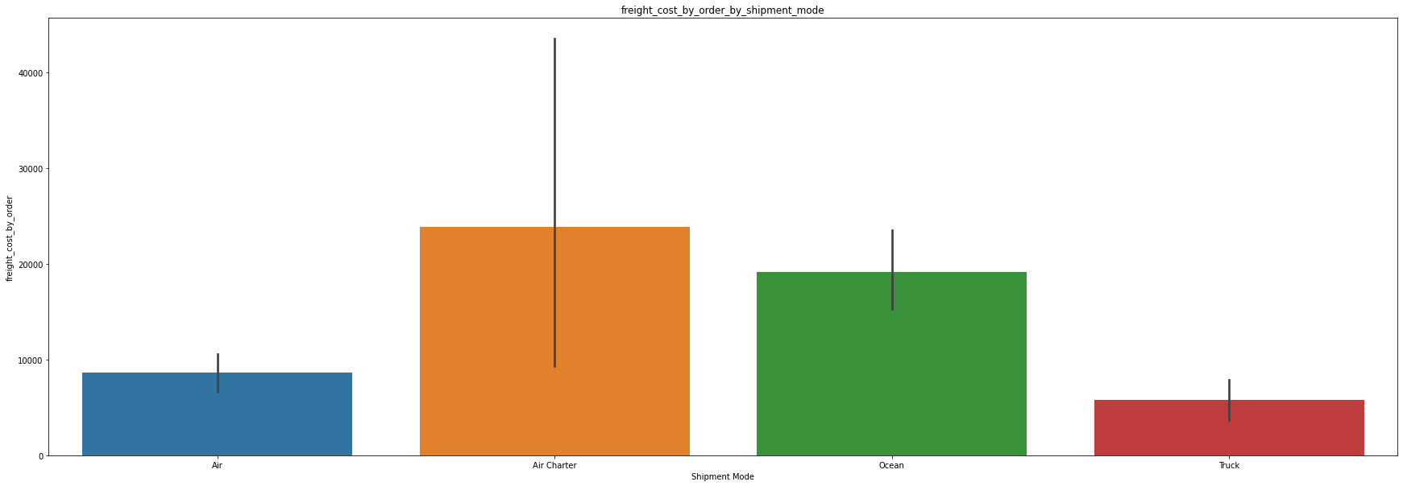

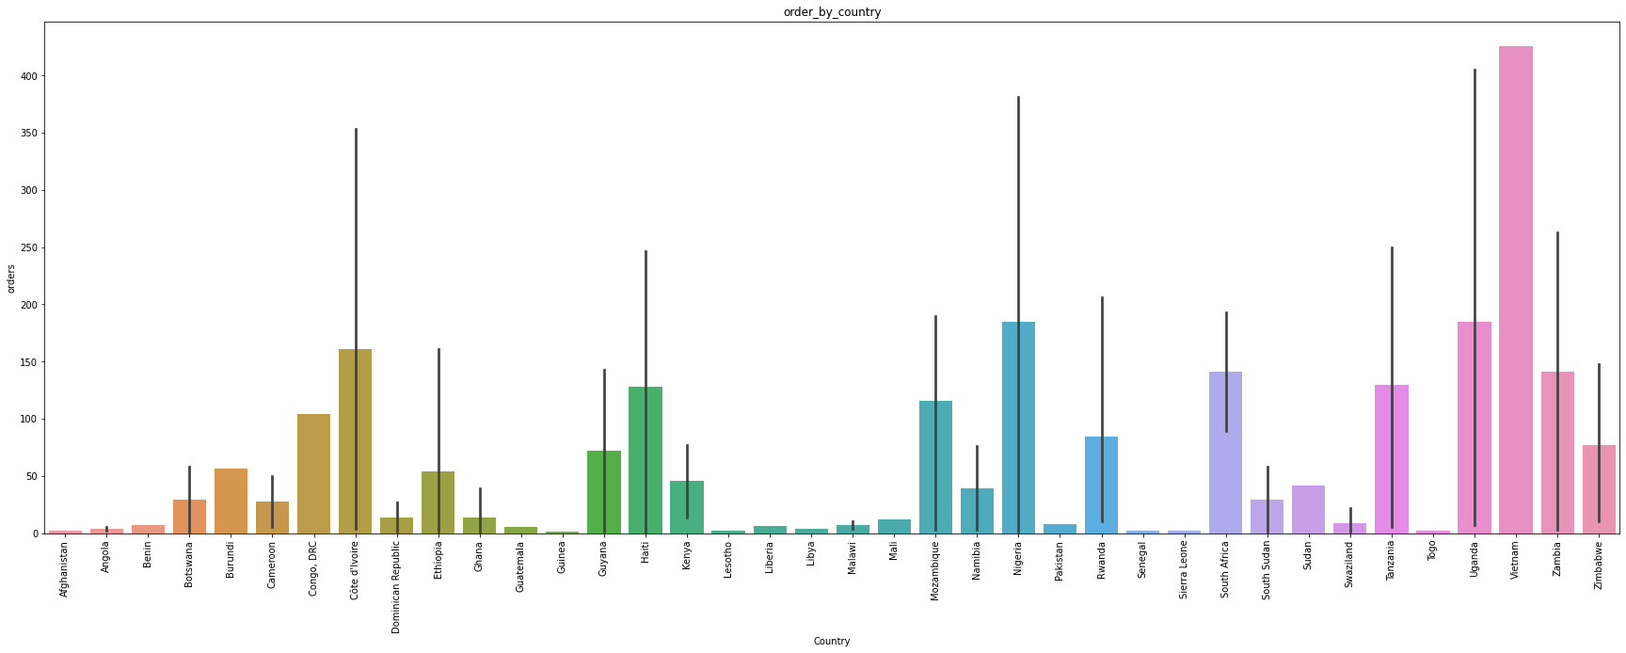

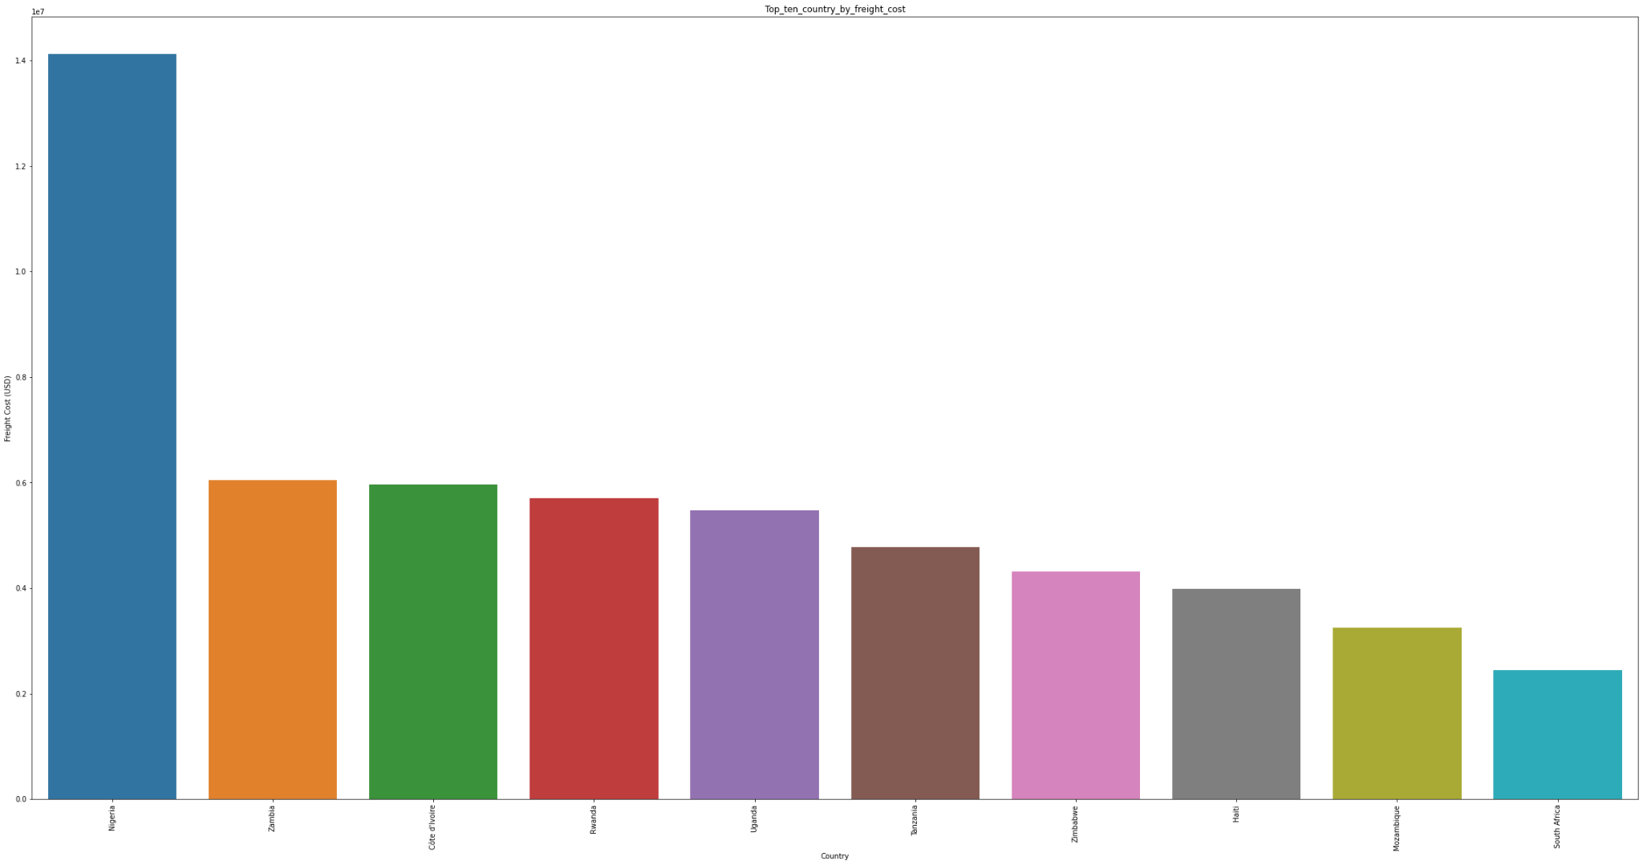

* **Tasks to be performed in the upcoming week:**

1. To perform data splitting for training and checking on different models.
2. We will be performing model fitting using following models:

* Decision Tree Regressor
* Random Forest Regressor
* LinearRegression
* GradientBoostingRegressor

1. Getting R2 Score for the chosen models and also calculating RMS value to decide upon which model to use for final step.